caNanoLab – cancer Nanotechnology Laboratory Analysis Bench

Software Design Description

Release 1.2

Document Change Record
Version Number | Date | Description
1.0 | 09/06/06 | Initial document
1.1 | 02/15/07 | Initial document
1.2 | 08/23/07 | Initial document

TABLE OF CONTENTS
1. Introduction 1
1.1 PROJECT BACKGROUND 1
1.2 identification 2
1.3 Requirements 2
1.4 System Overview 4
1.5 Document Overview 5
1.6 Reference documents 5
2. System Architecture 7
2.1 SYSTEM Architecture OVERVIEW 7
2.1.1 Client Tier 7
2.1.2 Presentation Tier 8
2.1.3 Business Tier 8
2.1.4 Persistence Tier 8
2.1.5 Enterprise Information System (EIS) Tier 9
2.2 SYSTEM Deployment 9
3. Components 10
3.1 Domain MODEL 10
3.1.1 Nanoparticle Object Model (nano-OM) 10
3.1.2 Laboratory Object Model (lab-OM) 21
3.2 daTA MODEL 22
3.2.1 Nanoparticle Data Model (nano-OM) 22
3.2.2 Laboratory Data Model (lab-OM) 27
3.3 User Interface 28
3.4 Business Services 29
3.4.1 Typical Business Service 30
3.4.2 Remote Query Facade 30
3.4.3 Remote File Content Retrieval 32
3.5 FILE repository STRUCTURE 33
3.6 Authentication and authorization 34
4. Grid-Enabling architecture 36
4.1 caNanoLab grid architecture overview 36
4.2 caNanoLab grid data service 37
4.3 caNanoLab SDK data service 38
Appendix A – acronym List 39

Introduction
The purpose of this document is to describe the design for the cancer Nanotechnology Laboratory Analysis Bench (caNanoLab) Release 1.2.

PROJECT BACKGROUND
The caNanoLab effort is collaboration amongst the NCI Center for Biomedical Informatics and Information Technology (NCICBIIT), the Nanotechnology Characterization Laboratory (NCL), and Cancer Centers of Nanotechnology Excellence (CCNEs). The project goal is to develop a nanoparticle characterization data portal and an initial standard representation of nanoparticles and their characterization intended for cancer therapeutics and diagnostics. The characterization portal is designed to facilitate data sharing amongst the CCNEs and nanotechnology community under the spirit of the NCI’s cancer Biomedical Informatics Grid (caBIG™) program.

The caNanoLab 1.0 release expanded upon the caLab .50 release that focused on capturing the NCL workflow and workflow artifacts. Release 0.5 features included:

- Sample Management – Accessioning samples (nanoparticles), creating aliquots, searching samples and aliquots
- Execute Workflow – Creating assay runs, assigning inputs (aliquots and input files) and outputs (result files) to assay runs, searching workflow components for assay results
- File Upload – Uploading assay result files
- Basic Security – User authentication via the NCI’s Common Security Module (CSM)
The design of release 1.0 features involved extension of the caLab .50 web portal and the generic laboratory object model (lab-OM) with nanoparticle annotations and role-based security. In release 1.0, nanoparticle annotations are represented in a nanoparticle object model (nano-OM) defining nanoparticle compositions, functions, and physical and in vitro characterizations. Release 1.0 features included:
- Annotate Nanoparticles – Annotating nanoparticles with characterizations resulting from physical and in vitro nanoparticle assays, searching and retrieving nanoparticle characterizations in a secure fashion.
- Advanced Security – User authorization via the Common Security Module (CSM), User management via the User Provisioning Tool (UPT)
The caNanoLab 1.1 release focused on searching remote caNanoLab grid services for publicly available nanoparticle data. This release requires grid-enabling of the nano-OM and the generation of a caBIG grid (caGrid™) data service with custom operations that allow caNanoLab data to be shared in a federated approach. Release 1.1 features include:

- Auto discovery of grid service – Automatically discovering caNanoLab grid services registered with a caGrid index server
- Remote Nanoparticle Search – Searching publicly available nanoparticles from remote caNanoLab grid data services connected to the caGrid
- Remote Nanoparticle Composition Data Search – Searching publicly available nanoparticle composition data from remote caNanoLab data services connected to the caGrid
- Remote Report Search – Searching publicly available nanoparticle reports from remote caNanoLab data services connected to the caGrid

The caNanoLab release 1.2 focused on protocol management and end-user usability enhancements that allow for more efficient data entry for characterization annotation. Release 1.2 features include:
- Protocol Submission – Submitting protocols with protocol type, name and version, and uploading associated protocol files
- Protocol Search – Searching protocols and protocol files based on protocol types, names and titles.
- Usability Enhancements – Adding/Removing characterization files and derived data, associating previously submitted protocols to characterizations, deleting characterizations, copying characterizations from a particle to other particles from the same source, and enhancing data entry for function annotation.

identification
The system identification information to which this document applies is as follows:
- Title: cancer Nanotechnology Laboratory Analysis Bench
- Abbreviation: caNanoLab
- Version: 1.2
- Release Number: 1.2

Requirements
The following is a list of high-level functional and technical requirements for caNanoLab 1.2:
Req. # | Requirement
1.0 | The system shall provide advanced security that provides support for role based authorization
1.1 | The system shall leverage the NCICB Common Security Module (CSM) and the User Provisioning Toolkit (UPT)
1.1.1 | The system shall allow administrators to configure groups and group privileges (read only, read-write)
1.1.2 | The system shall provide support for user management
2.0 | The system shall support submission and retrieval of nanoparticle annotations
2.1 | The system shall allow users to annotate and search nanoparticles based on the nanoparticle composition specific to each nanoparticle type
2.2 | The system shall allow users to annotate and search nanoparticles based on nanoparticle characterizations, functions, keywords and summary/descriptions associated with characterizations
2.3 | The system shall provide support for physical characterizations
2.4 | The system shall provide support for in vitro characterizations
2.5 | The system shall allow authorized users to submit assay results (e.g. distribution graphs) and associate assay results with annotations (e.g. size distribution graph, z-avg. size, PDI)
2.6 | The system shall allow authorized users to submit instrument type, manufacturers associated with the characterizations
2.7 | The system shall allow authorized users to set visibility of submitted assay results.
2.8 | The system shall allow users to upload and retrieve nanoparticle reports
2.9 | The system shall allow authorized users to set visibility of uploaded reports
2.10 | The system shall allow users to associate reports with multiple nanoparticles
2.11 | The system shall allow users to submit and search protocols
2.12 | The system shall allow authorized users to set visibility of submitted protocols
2.13 | The system shall allow authorized users to copy characterizations from one particle to other particles from the same particle source
2.14 | The system shall allow authorized users to delete single and multiple characterizations
3.0 | The system shall be engineered for caBIG compatibility
3.1 | The system shall leverage the caCORE SDK and associated components
3.2 | Concepts for supported objects/attributes shall be registered in the EVS
3.3 | The object model shall be loaded into the caDSR
4.0 | The system shall grid-enable the caNanoLab object model and register  The grid service in the grid index server
4.1 | The system shall auto-discover remote caNanoLab data services
4.2 | The system shall search public nanoparticles and reports against remote caNanoLab grid services
4.3 | The system shall search public nanoparticle composition data against remote caNanoLab grid services

Table 1-1: Requirements Matrix
These requirements are further expanded in the caNanoLab 1.0, 1.1 and 1.2 Use Case Specification documents.

System Overview
The primary goals of the caNanoLab Release 1.2 effort are to:
- Provide for the efficient storage and retrieval of nanoparticle characterizations to expedite and validate the use of nanotechnology in medicine
- Develop and support an initial standard for representing nanoparticle characterizations to facilitate data sharing in a semantically interoperable fashion in the spirit of caBIG™
- Implement a system that facilitates data sharing in the nanotechnology community in a secure fashion

System Development
The caNanoLab 1.2 effort is being designed and developed following the Rational Unified Process (RUP) in an iterative fashion. As such, it is intended that this document will be updated frequently during the elaboration phase.

Operations and Maintenance
The reference implementation of caNanoLab 1.2 is being deployed and maintained at the Advanced Biomedical Computing Center (ABCC) in NCI Frederick for use at the NCL.

Key Stakeholders
Key stakeholders associated with the effort are defined as follows:

- Nanotechnology Characterization Laboratory (NCL) – End users of the caNanoLab system
- Cancer Centers of Nanotech Excellence (CCNEs) – Consumers of caNanoLab data and end users of the caNanoLab systems installed at the centers
- Advanced Biomedical Computing Center (ABCC) – Provides caNanoLab operations and maintenance support
- National Cancer Institute Center for Bioinformatics and Information Technology (NCICBIIT) – Provides development and metadata support

Document Overview
This document provides an overview of caNanoLab system design. It is intended to describe and capture the caNanoLab design decisions and is written as a reference for both the NCI customer and the NCI contractors/developers involved with the evolution of caNanoLab. This is a living document and will be updated to reflect the evolution of development, as well as future enhancements and upgrades.
The main sections of this document are listed and described below.
- Section 1. Introduction: provides a purpose statement, project background, requirements matrix, system overview, and document overview.

- Section 2. System Architecture: describes an overview architecture design of the J2EE system and the various environments that will be used throughout the development lifecycle.
- Section 3. Components: describes design details of the system components: domain model, data model, user interface, business services, file repository structure, and user authentication and authorization.
- Section 4. Grid-Enabled Architecture: describes an overview of the grid-enabling architecture and design details of the caNanoLab grid data service and caNanoLab SDK application service.

Reference documents
Document Name | Location
caNanoLab Scope Documents | CVS Server: cbiocvs2; module: cananolab; Directory: docs/Scope
caNanoLab Use Case Specification documents | CVS Server: cbiocvs2; Module: caNanoLab; Directory: docs/usecase
caNanoLab Architecture Checklist | CVS Server: cbiocvs2; Module: caNanoLab; Directory: docs/design
caCORE 3.1 (including CSM) and caCORE SDK 1.1 | ftp://ftp1.nci.nih.gov/pub/cacore/caCORE3.1_Tech_Guide.pdf  ftp://ftp1.nci.nih.gov/pub/cacore/SDK/caCORE_SDK1.1_Programmers_Guide.pdf
caBIG Compatibility Guidelines | https://cabig.nci.nih.gov/guidelines_documentation/caBIGCompatGuideRev2_final.pdf
caGrid 1.0 User Guide | http://gforge.nci.nih.gov/frs/download.php/1416/caGrid-1-0_Users_Guide.pdf
caGrid 1.0 Programmer Guide | http://gforge.nci.nih.gov/frs/download.php/1417/caGrid-1-0_Programmers_Guide.pdf

Table 1-2: Reference Documents

System Architecture

SYSTEM Architecture OVERVIEW
The caNanoLab system is designed as a Java 2 Enterprise Edition (J2EE) n-tier system that fosters a loosely coupled and tightly cohesive architecture in which objects in each tier are focused on specific architectural responsibilities yet, cleanly integrated with the other tiers. The architecture of a caNanoLab grid data service is described separately in section 4, not as a part of the caNanoLab system. The following architecture diagram shows the overall system architecture of the caNanoLab system. An overview of each tier is provided in the sections immediately following the diagram.

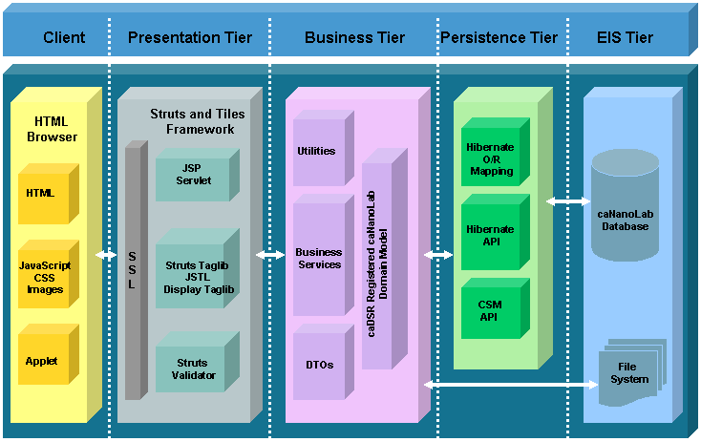
Figure 2-1: System Architecture

Client Tier
The caNanoLab client tier, like all other J2EE web based systems, consists of web browsers (e.g. Internet Explorer, FireFox, etc.) serving HTMLs, JavaScripts, images, Cascading Style Sheets (CSS), as well as applets. In the caNanoLab system, an applet is used for uploading multiple files at the same time from a client’s machine.

Presentation Tier
The caNanoLab presentation tier is implemented using the Model-View-Controller pattern and through the Struts Servlet/JSP Framework and the Tiles Framework. The Struts ActionServlet intercepts every request from the client tier and populates a Struts ActionForm with HTTP request parameters defined from user inputs. These request parameters are validated through the Struts Validator Framework. Once validated, the ActionServlet initiates an appropriate Struts Action to process the request and pass the response back to a JSP page for rendering. Struts tag library, display tag library and JavaServer Pages Standard Tag Library (JSTL) are used to help dynamically render HTML pages displayed in the client browsers.
Tiles Framework is used to separate layout from content such that the same layout components are reused in different JSP pages with different contents, and developers only need to maintain one set of HTML layout codes.

Business Tier
The business tier is responsible for implementing the business logic in the application and bridges the gap between the presentation tier and the underlying data sources. The caNanoLab business tier consists of business service objects, data transfer objects (DTO), utilities objects, and the caNanoLab Plain Old Java Object (POJO) domain model that has been registered in the Cancer Center Data Standards Repository (caDSR).
Each HTTP request is converted into a business service request and passed to the appropriate business service objects for processing. Business service objects interact with Hibernate API (described in the Persistence Tier) and utilities objects to retrieve and store domain model objects. In addition, business service objects, along with utilities objects, implement business logics involved in retrieving and storing files. Domain objects are transformed into DTOs before they are passed back to the presentation tier.

Persistence Tier
The caNanoLab persistence tier is implemented using the Hibernate object-relational mapping (ORM) framework. Domain objects are mapped to database tables through the Hibernate ORMs. Hibernate API is responsible for generating SQL queries and handling database transactions, and is used within the business service objects to communicate with the underlying databases.
Before a user can send a request to store data into the database, or before queried data is presented back to the presentation tier, the application checks whether the user have the right access privileges to the data. User authentication and authorization in the caNanoLab system is implemented through the API provided by the Common Security Module (CSM) available as a part of the Cancer Common Ontologic Representation Environment (caCORE) infrastructure. The CSM API is also implemented using the Hibernate framework, and the CSM database objects reside in the same database as the caNanoLab database objects.

Enterprise Information System (EIS) Tier
The EIS tier is the backend tier that is responsible for providing and storing data. The caNanoLab EIS tier consists of a caNanoLab database and a file system. The caNanoLab database contains database objects for storing the caNanoLab application data, and also contains database objects for storing CSM authentication and authorization data. The file system stores assay result files, characterization files, reports and protocols uploaded in the application.

SYSTEM Deployment
The caNanoLab system is designed to be deployed in any Servlet container that conforms to Java Servlet specification 2.4 and JSP specification of 2.0. For both NCICBIIT and NCL deployments, JBoss Java 2 Enterprise Edition (J2EE) application server integrated with Apache web server is used to host the presentation tier, the business tier and the persistence tier of the system. At the NCICBIIT, the caNanoLab system is deployed in a four-tier hardware environment comprising development, QA, staging and production. At the NCL, the system is deployed in a two-tier hardware environment comprising of staging and production.

Components

Domain MODEL
The caNanoLab domain model is designed following the caCORE design principles that include UML modeling, open APIs, controlled vocabularies and caDSR registered metadata. The caNanoLab domain model has been semantically annotated with concepts from the Enterprise Vocabulary System (EVS). The metadata describing the caNanoLab domain model has been registered into the caDSR.
The caNanoLab domain model has been modeled after the NCL assay cascade, and includes two sub models: nanoparticle object model (nano-OM) and laboratory object model (lab-OM). The nano-OM is designed to capture physical, in vivo and in vitro nanoparticle characterization data, nanoparticle composition data, and nanoparticle function data. The lab-OM describes data level laboratory objects (e.g. organization, assay, sample, etc.). The following subsections describe details of the nano-OM and the lab-OM.

Nanoparticle Object Model (nano-OM)
The nano-OM model focuses on developing a standard representation of nanoparticles and the outcome (characterizations) of assays applied to these nanoparticles. The annotation for each object and attributes are maintained in EVS, and these concepts form the basis of a standard ontological hierarchy of terminology applicable to the use of nanotechnology in medicine.

The nano-OM is composed of the following high-level packages:

- Particle – Defines the basic classification of a nanoparticle as a type of sample. Classifications range from organic, to inorganic, to complex or hybrid particles.
- Function – Represents the function of a nanoparticle as a targeting, therapeutic, or diagnostic agent. Identifies particle agents (e.g. antibody, peptide) and Agent Targets (antigens, receptors) and the associated linkages.
- Characterization - Describes the conditions in which the particle was characterized, the instrument and protocol leveraged, and characterization files (e.g. graphs, charts, spreadsheets, etc.) and derived data that provide insight into the complexities of the characterization.

The Characterization package is further sectioned into discrete packages modeled after the NCL assay cascade:

- Physical Characterizations – Provides information about the nanoscale entities such as particle type (e.g. dendrimer, fullerene, complex) composition, structure, and other material properties.
- In Vitro Characterizations – Identifies the cellular toxicity (cytotoxicity) and immunotoxicity.
- In Vivo Characterizations – Describes general particle pharmacokinetics, toxicology and efficacy. [This part of the domain model has been designed but not implemented in caNanoLab 1.2].

The subsections that follow illustrate objects and attributes associated with each package.

Particle Package
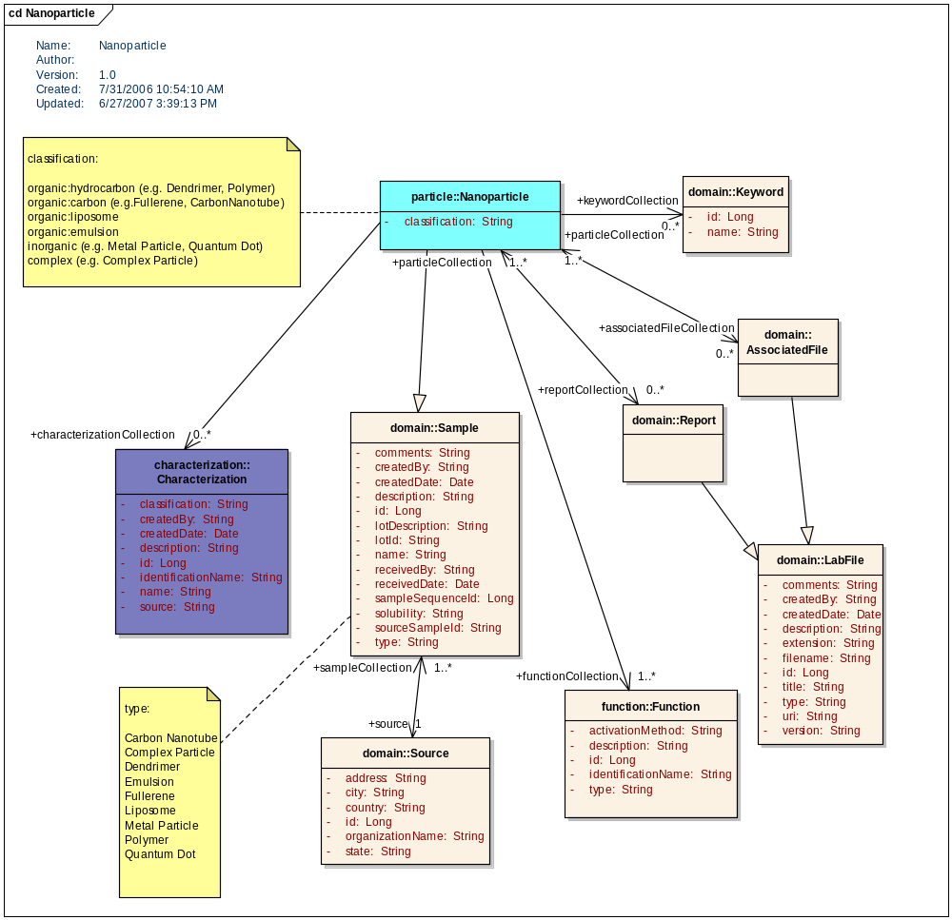
Figure 3-1: Particle Package (nano-OM)

Function Package
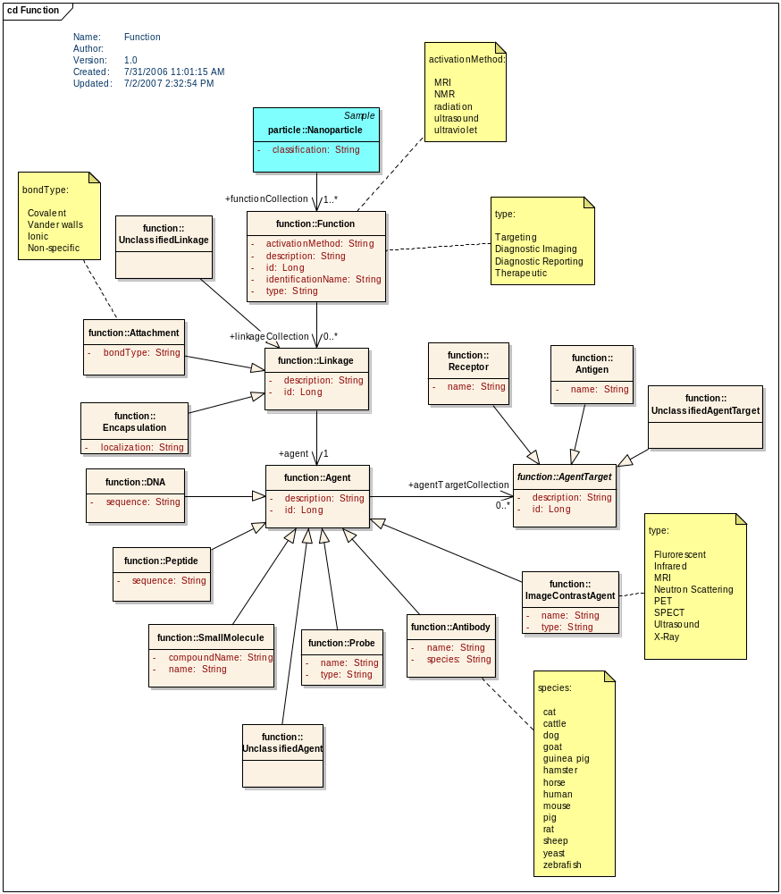
Figure 3-2: Function Package (nano-OM)

Characterization Packages

Base Characterization Package
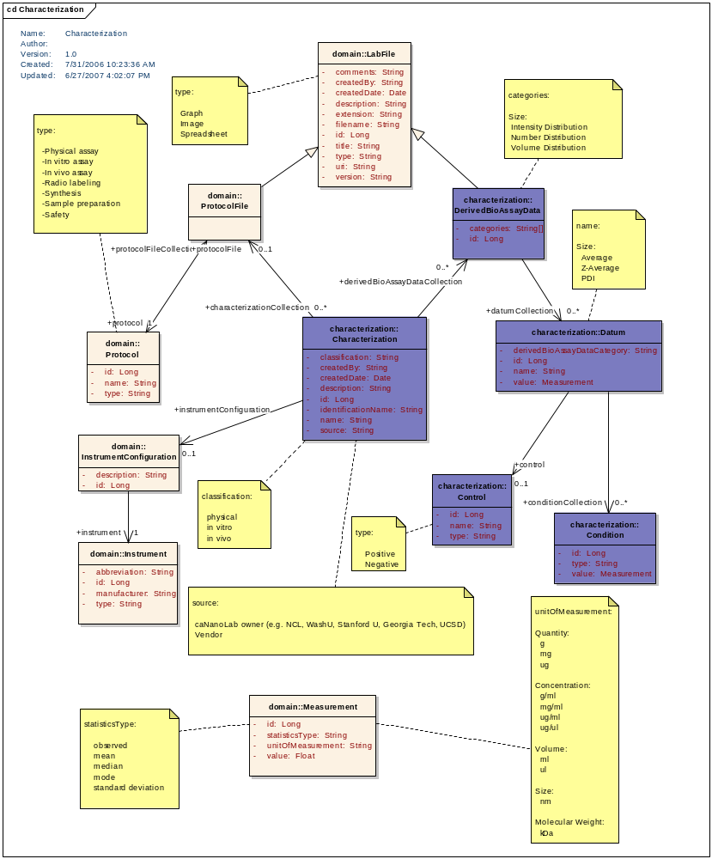
Figure 3-3: Base Characterization Package (nano-OM)

Physical Characterization
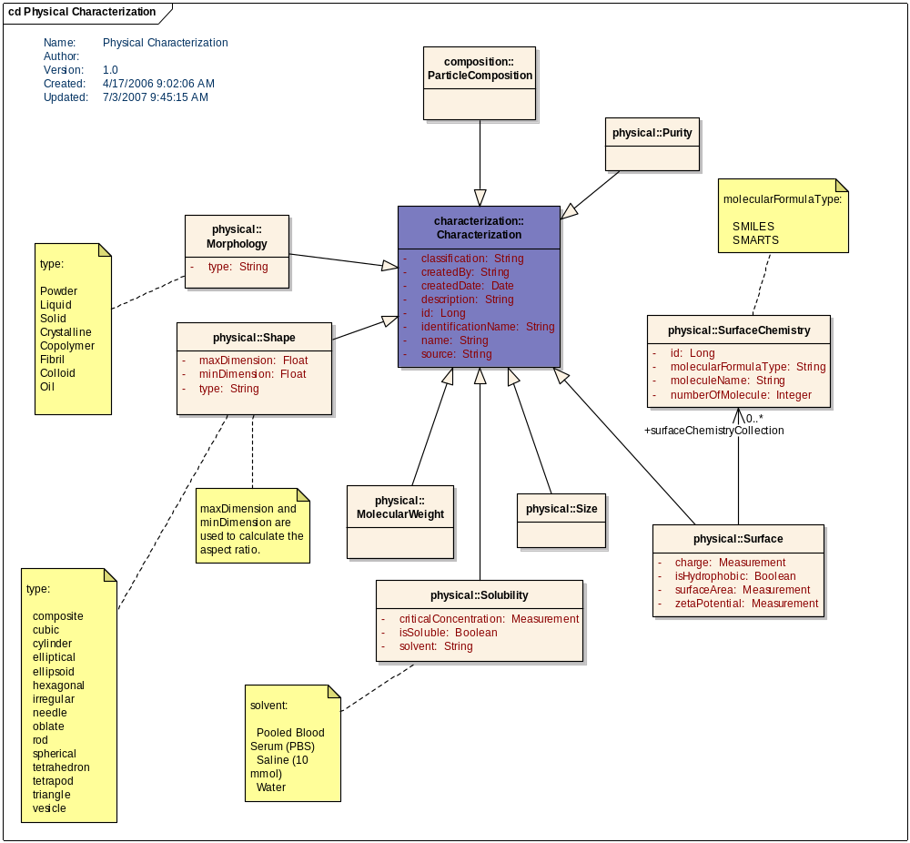
Figure 3-4: Physical Characterization Package (nano-OM)

Particle Composition Package
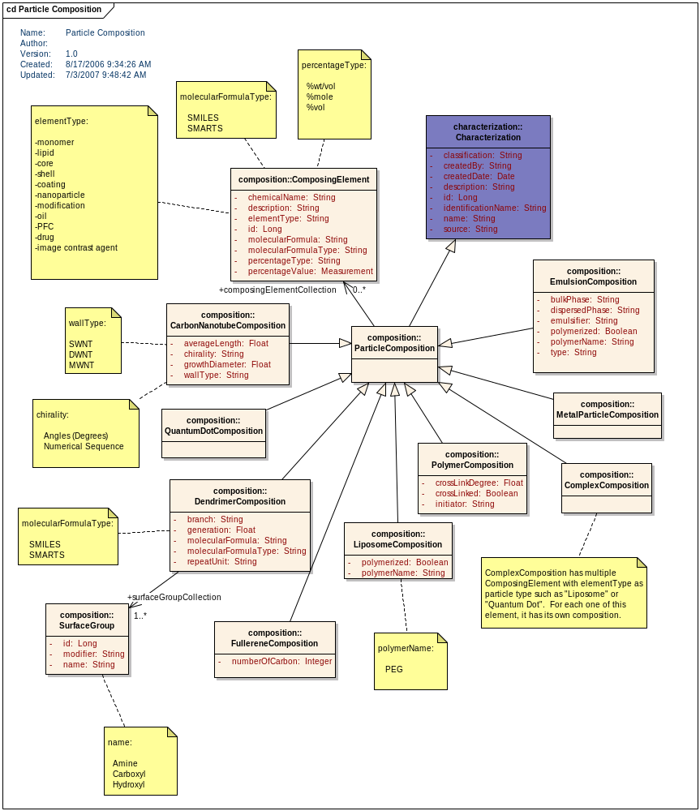
Figure 3-5: Particle Composition Package (nano-OM)

In Vitro Characterization Package
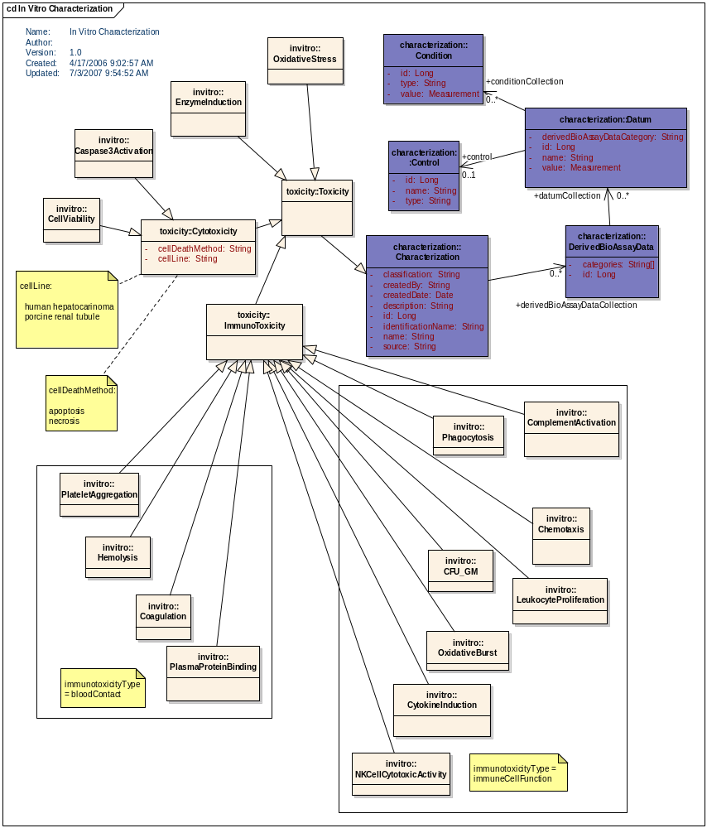
Figure 3-6: In Vitro Characterization Package (nano-OM)

In Vivo Characterization Package
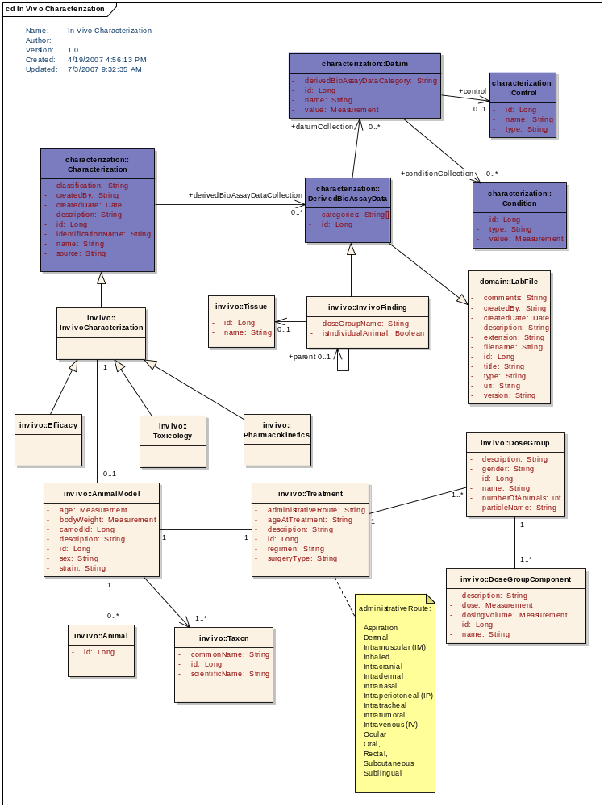
Figure 3-7: In Vivo Characterization Package (nano-OM)

In Vivo Pharmacokinetics Characterization Package
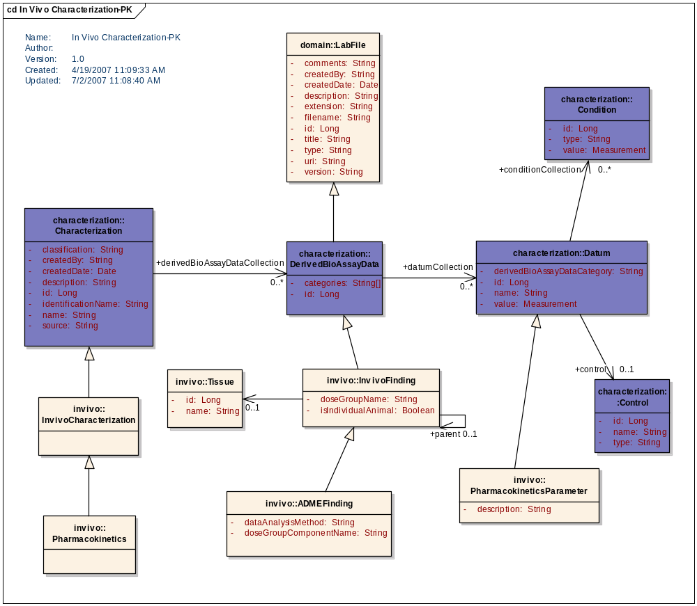
Figure 3-8: In Vivo Pharmacokinetics Characterization Package (nano-OM)

In Vivo Toxicology Characterization Package

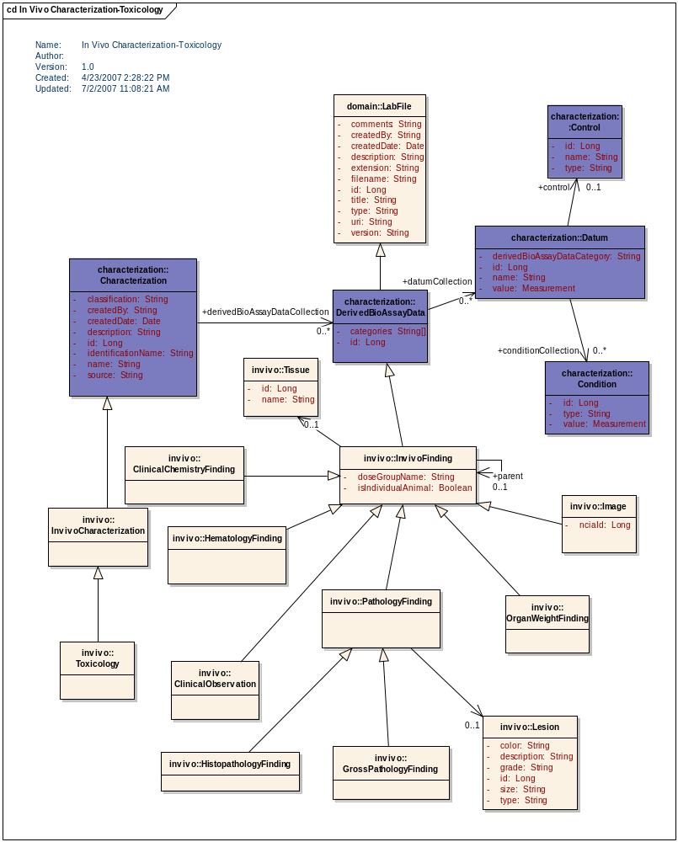
Figure 3-9: In Vivo Pharmacokinetics Characterization Package (nano-OM)

In Vivo Efficacy Characterization Package

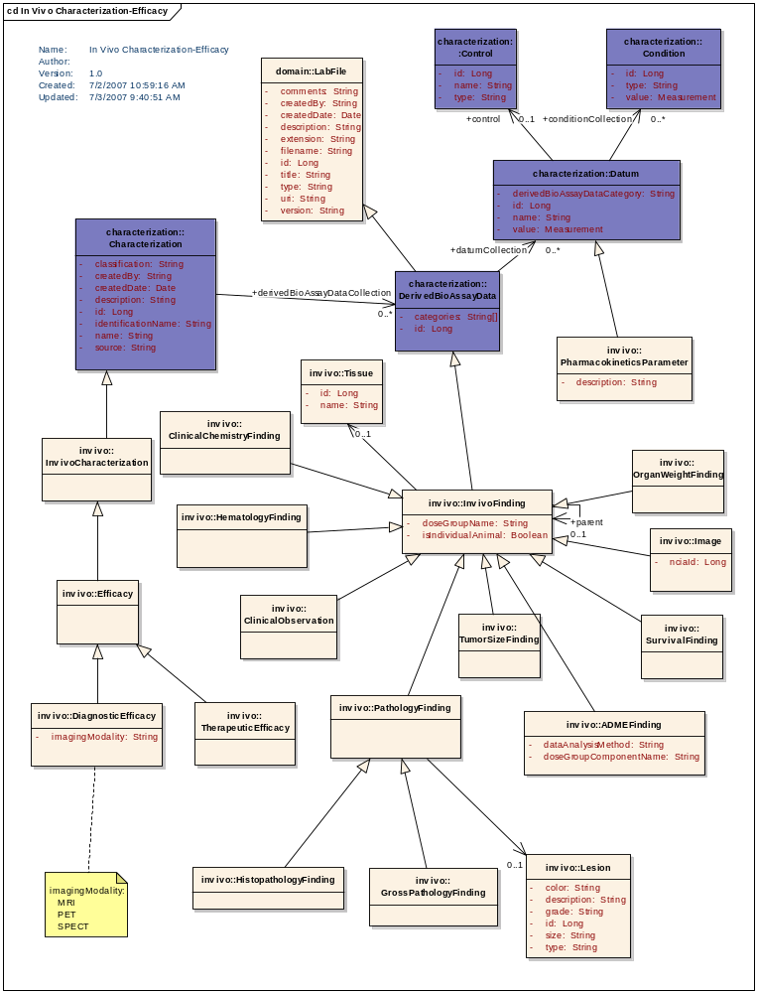
Figure 3-10: In Vivo Pharmacokinetics Characterization Package (nano-OM)

Laboratory Object Model (lab-OM)
The lab-OM model focuses on developing a set of generic laboratory objects involved in a lightweight representation of laboratory management information system, such as sample, sample container, aliquot, assay, etc.
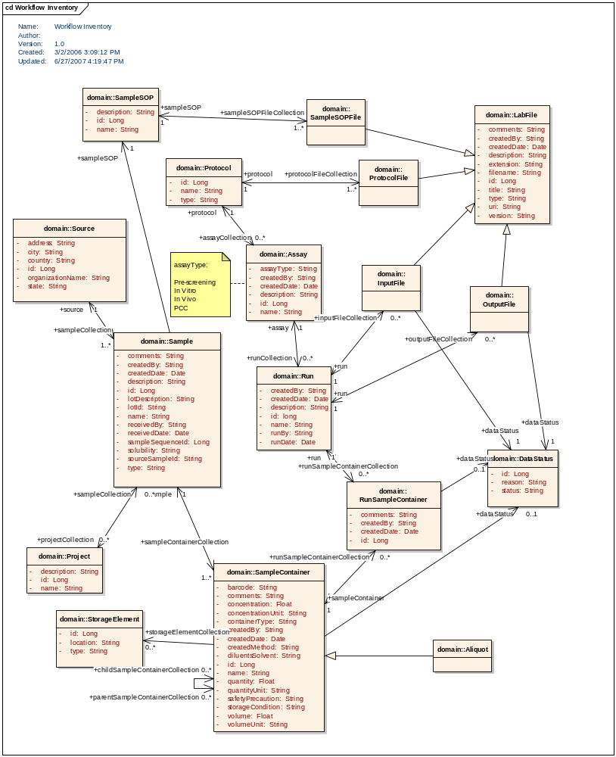
Figure 3-11: Laboratory Object Model (lab-OM)

daTA MODEL
The caNanoLab data model is closely coupled with the caNanoLab domain model. Tables are designed to work with the nano-OM and the lab-OM objects through the Hibernate ORMs. Following the Hiberate ORM principles, there is a close mapping between an object and a table, as well as a close mapping between object relationships (e.g. association, inheritance) and referential integrity table relationships.
Definition tables (prefixed with DEF) have been created to store known controlled vocabularies, as well as new ones users enter in from the caNanoLab application. Data stored in these lookup tables will be periodically fed into the EVS to generate new EVS concepts. In addition, history tables (prefixed with HISTORY) have also been created to store deleted characterizations and associated data when a user selects to delete characterizations. Deleted characterization data stored in the history tables can be restored later if there is a need to resurrect deleted data.
The caNanoLab data model is categorized into three sub-models: nanoparticle data model, laboratory data model and CSM data model. The following subsections provide details on each sub-model.

Nanoparticle Data Model (nano-OM)
Because there are a large number of database objects in the nanoparticle data model, it is difficult to fit them all in one ER diagram. The ER diagram is broken into several views: nanoparticle view presenting tables supporting nanoparticle general information; function view presenting tables supporting nanoparticle functions; characterization view presenting tables supporting base characterizations; physical and in vitro characterization view presenting tables supporting the physical and in vitro characterizations. In release 1.2, the in vivo domain model has been designed but has not yet been implemented as a data model.

Nanoparticle View
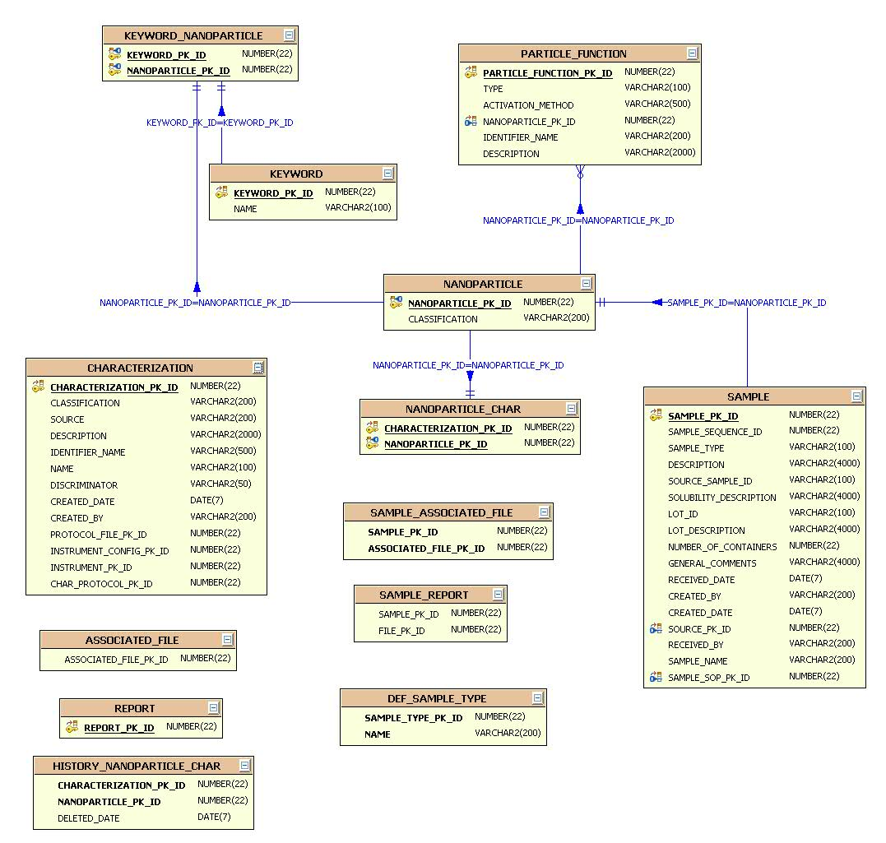
Figure 3-12: Nanoparticle View of Nanoparticle Data Model

Function View
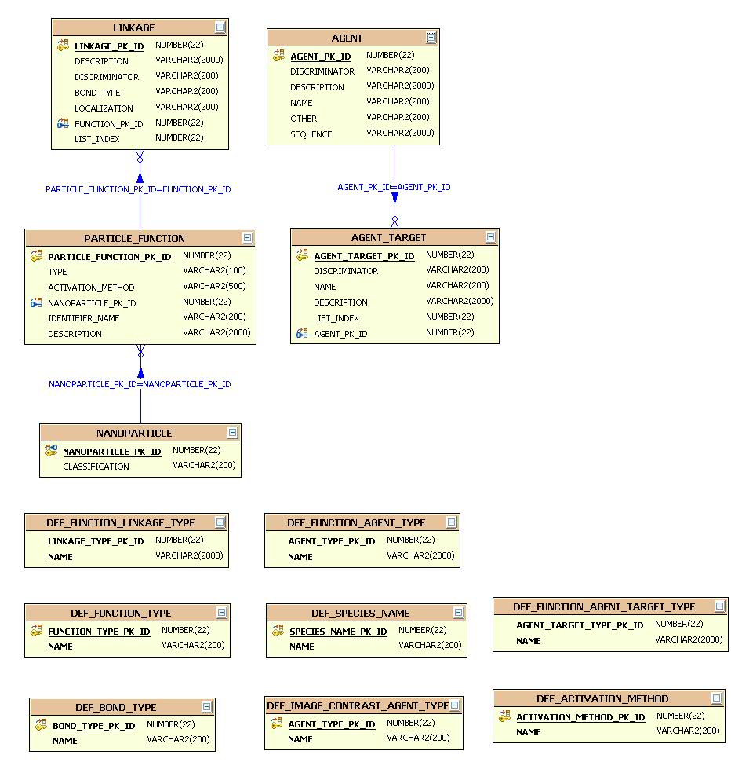
Figure 3-13: Function View of Nanoparticle Data Model

Base Characterization View
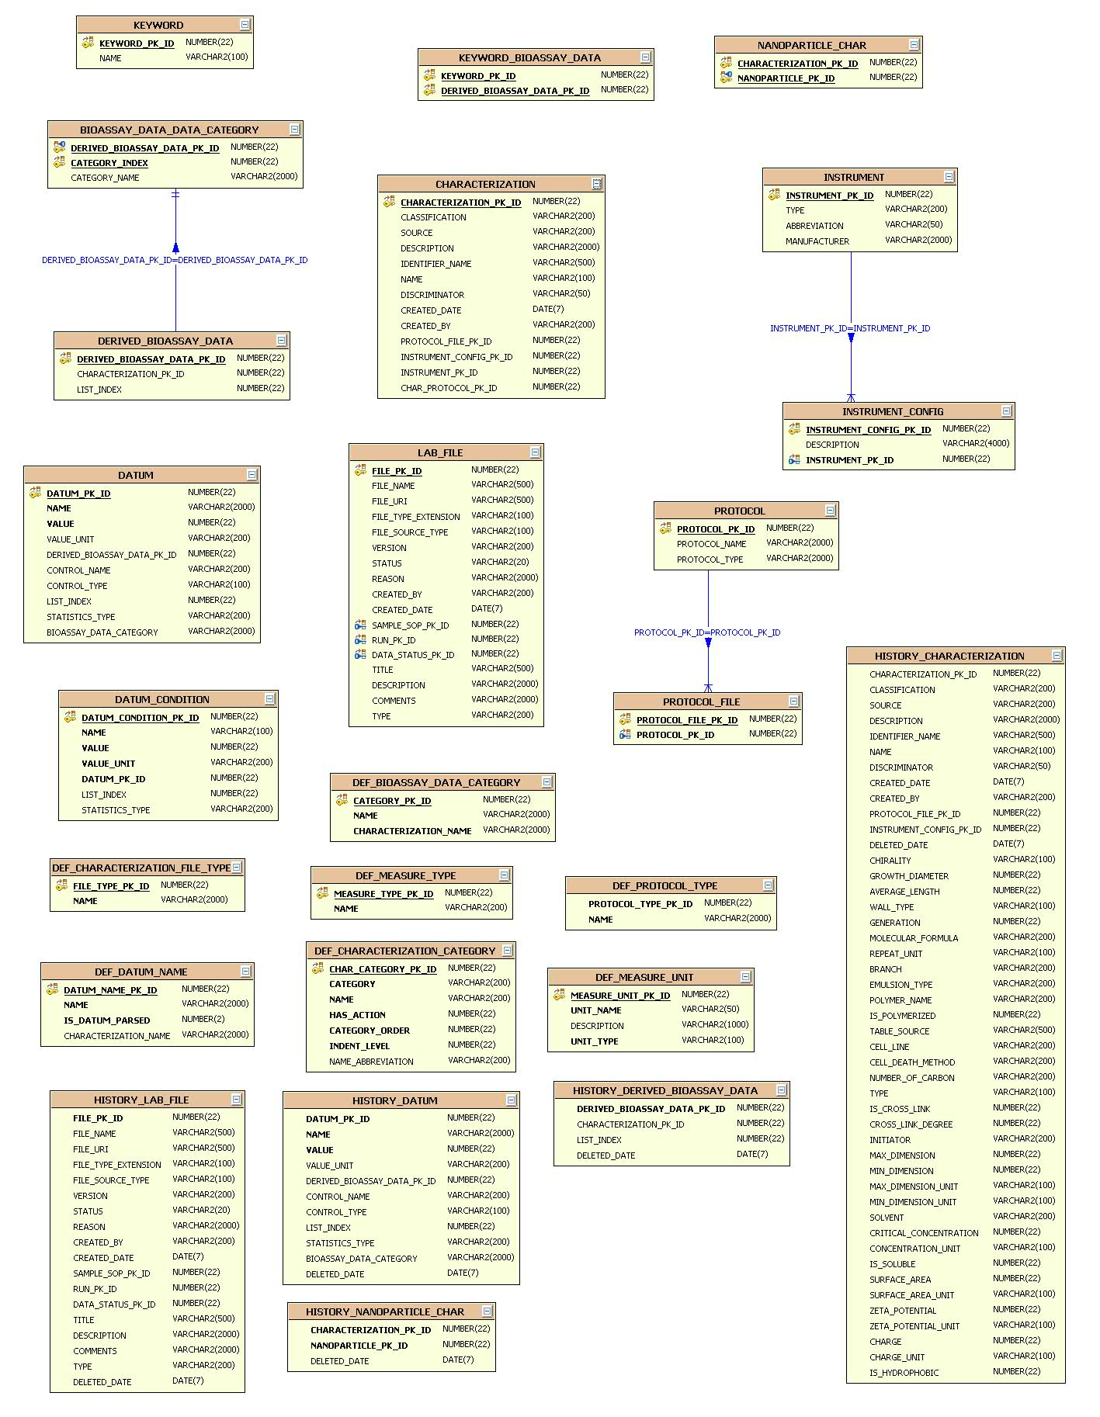
Figure 3-14: Base Characterization View of Nanoparticle Data Model

Physical and In Vitro Characterization View
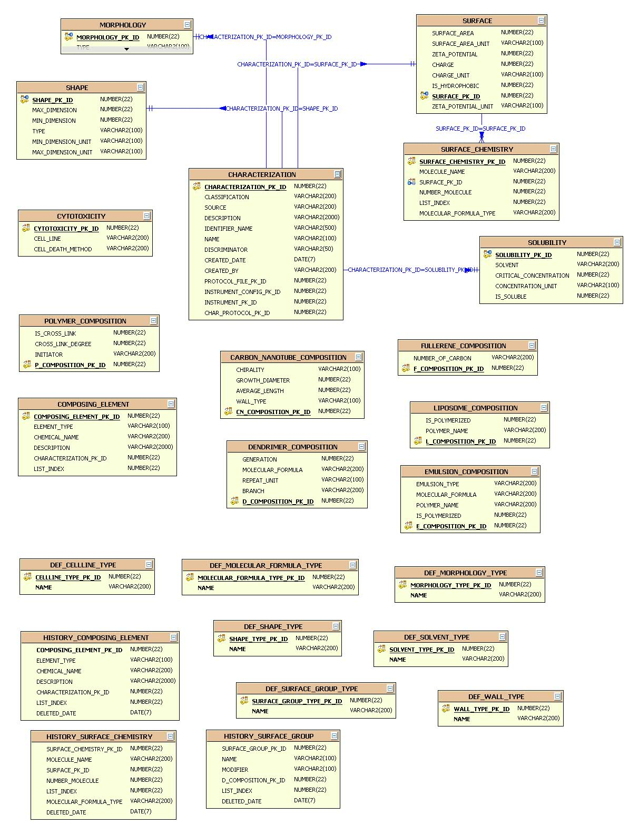
Figure 3-15: Physical and In Vitro Characterization View of Nanoparticle Data Model

Laboratory Data Model (lab-OM)

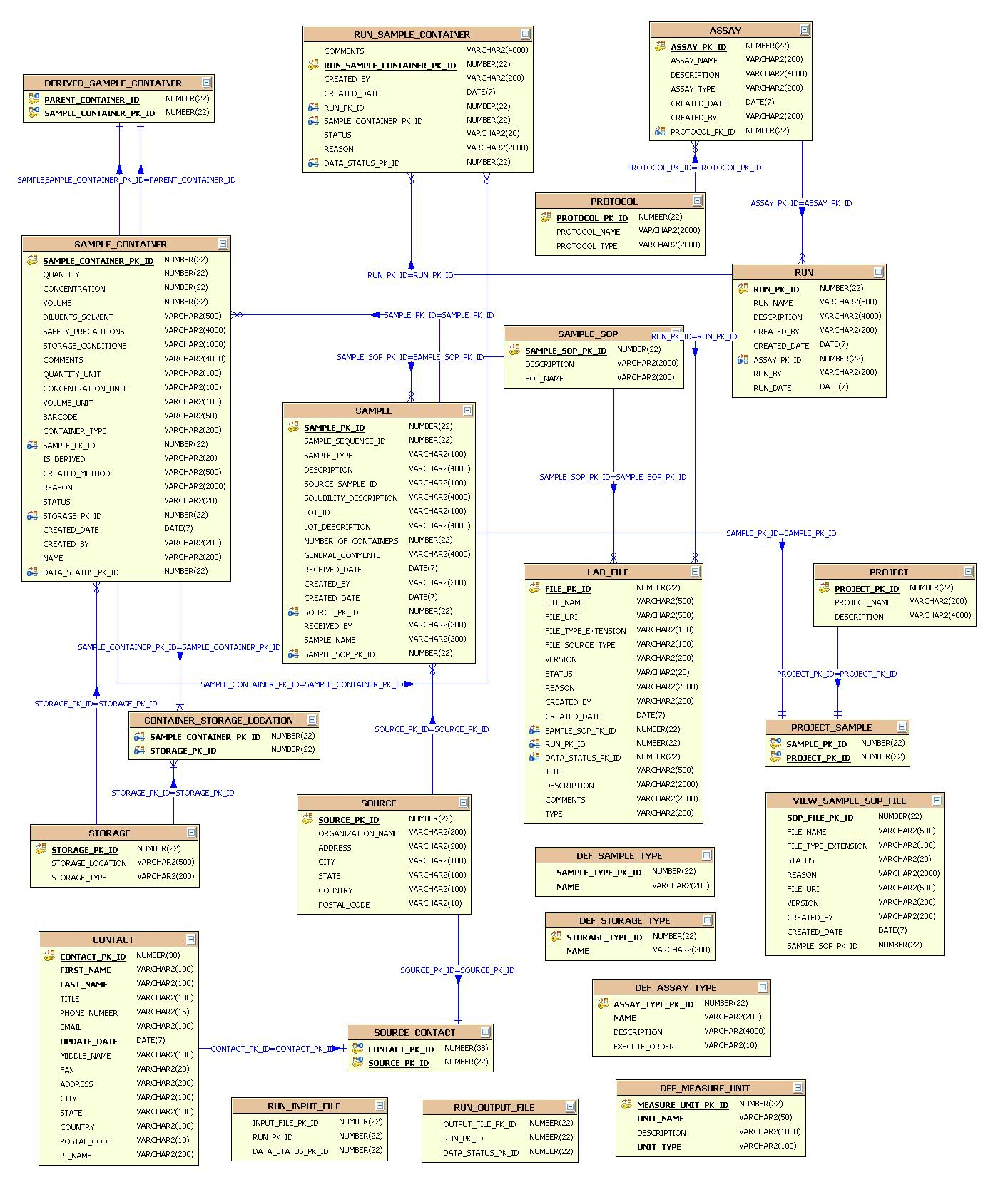
Figure 3-16: Laboratory Data Model

User Interface
The caNanoLab user interface (UI) has been modeled after NCL’s nanoparticle characterization use cases. Each page contains a header region containing project title and icons, a footer region containing links to application support, etc, a left menu region containing links to either external related sites or internal navigation links, a right content region containing contents of the caNanoLab application.
After a user logs in, at the top of the right content region, a menu bar with different tabs are displayed as shown in Figure 3-17. Different users with different access privileges can see different tabs. Please refer to section 3.6 for details on pre-defined security rules. The following tabs have been created to include different actions a user (with proper access privilege) can perform at a nanoparticle characterization lab:
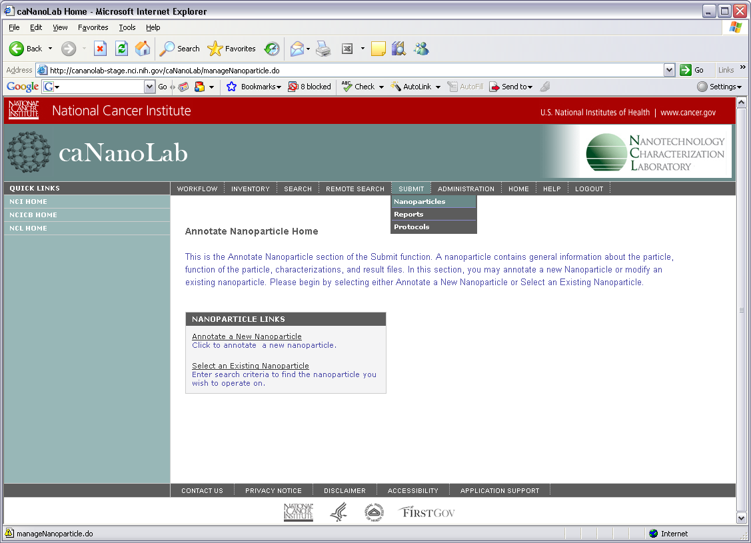
Figure 3-17: Submit Nanoparticle User Interface: WORKFLOW: creating and searching assay runs, uploading input and output files for assay runs; INVENTORY: creating and searching samples/aliquots; SEARCH/REMOTE SEARCH: searching nanoparticles, reports and protocols locally and remotely; SUBMIT: submitting nanoparticle annotations, reports and protocols; ADMINSTRATION: managing user accounts; HOME: going back to the home page; HELP: viewing on-line help documents; LOGOUT: logging out of the system.

The UI components are implemented using the Struts Framework. Struts ActionForms (declaratively defined as DynaActionForms) and action mappings are defined in the Struts configuration files under context root’s WEB-INF folder:
struts-config.xml
struts-config-inventory.xml
struts-config-search.xml
struts-config-submit.xml
struts-config-workflow.xml

The Struts Action classes handling each HTTP request are organized in the following UI java packages:
gov.nih.nci.calab.ui.core
gov.nih.nci.calab.ui.inventory
gov.nih.nci.calab.ui.search
gov.nih.nci.calab.ui.security
gov.nih.nci.calab.ui.submit
gov.nih.nci.calab.ui.workflow

The Tiles definitions defining each page’s layout and content are defined in the following files under the WEB-INF folder:

tiles-defs.xml
tiles-defs-inventory.xml
tiles-defs-search.xml
tiles-defs-submit.xml
tiles-defs-workflow.xml

The Struts Validator configuration files controlling how user entries at the input forms are validated are defined in the following files under the WEB-INF folder:

validator.xml
validator-rules.xml
validator-inventory.xml
validator-submit.xml
validator-workflow.xml

Business Services
The business service classes in the caNanoLab system implement business logics in creating/searching assay runs, creating/searching samples/aliquots, creating/searching nanoparticle characterizations, protocols and reports. These business services are organized into the following packages:
gov.nih.nci.calab.service.common
gov.nih.nci.calab.service.inventory
gov.nih.nci.calab.service.remote
gov.nih.nci.calab.service.search
gov.nih.nci.calab.service.security
gov.nih.nci.calab.service.submit
gov.nih.nci.calab.service.util
gov.nih.nci.calab.service.util.file
gov.nih.nci.calab.service.workflow
gov.nih.nci.calab.service.workflow.httpfileuploadapplet

Typical Business Service
The implementation of a typical business service method in the caNanoLab system involves calls to the Hibernate API to either retrieve/store data from/to the underlying database. A Hibernate Utility class HibernateUtil has been implemented to help business services to manage Hibernate sessions and transactions. Its methods and signatures are shown below:
public static Session currentSesion() throws HibernateException
public static void closeSession() throws HibernateException
public static Transaction beginTransaction()
public static void commitTransaction()
public static void rollbackTransaction()
public static Query createQueryByParam(String hqlString, List paramList)

DTOs are used as both method arguments and as returned data in the business service classes. For example, the basicSearch method in the service class gov.nih.nci.calab.service.search.SearchNanoparticleService takes in UserBean DTO and passes back a list of ParticleBean DTOs:
public List<ParticleBean> basicSearch(String particleSource,
String particleType, String[] functionTypes,
String[] characterizations, String[] keywords,
String keywordType, UserBean user) throws Exception;

The implementation of the business services in the REMOTE SEARCH function does not directly involve the Hibernate API as other business services and is described in more details in the following sections.

Remote Query Facade
In the caNanoLab REMOTE SEARCH function (available since release 1.1), users can search publicly available nanoparticles or reports across remote caGrid data services that host the caNanoLab domain model. The caNanoLab caGrid data service has been implemented without user authentication and authorization (please refer to section 4 for descriptions of a caNanoLab grid data service architecture). In order for the grid service to serve public data to grid clients, it needs to first filter out non-public data. A remote query façade is designed as a caNanoLab business service to provide public data filtering functions to remote clients through the Http invoker Remoting mechanism of the Spring Framework. A caNanoLab grid data service is considered a remote client of the remote query façade.
The remote query façade, under the package gov.nih.nci.calab.service.remote, includes a service interface RemoteQueryFacade that encapsulates service methods available to the remote clients, as well as a service implementation class RemoteQueryFacadeImp. The service methods are as follows:
public boolean isPublicId(String dataId) throws Exception;
public List<String> getPublicDataIds(String[] dataIds) throws Exception;
public byte[] retrievePublicFileContent(Long fileId) throws Exception;

The following sequence diagram illustrates the scenario of how a user, in a local caNanoLab system, retrieves remote nanoparticles from a remote caNanoLab grid service, and how the remote caNanoLab grid service uses the associated remote caNanoLab system for public filtering through the remote query façade.
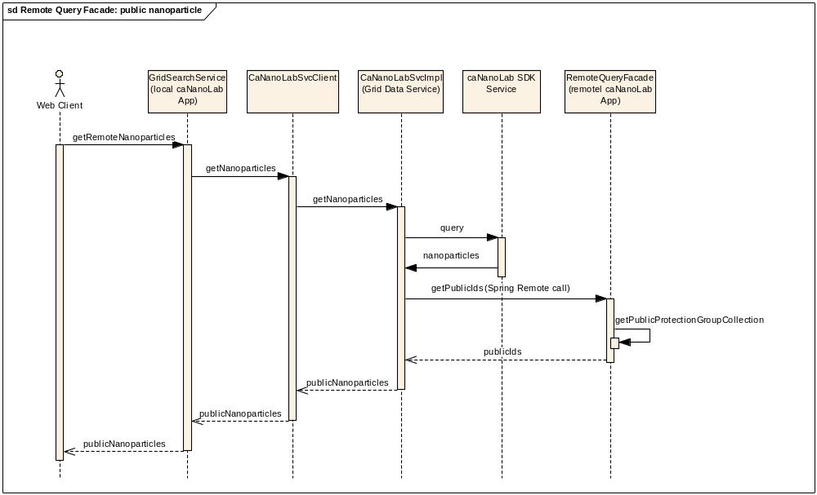
Figure 3-18: Sequence Diagram for Remote Nanoparticle Search in the caNanoLab Application

Instead of using the REMOTE SEARCH function provided in the caNanoLab application, users (e.g. grid clients like the caGrid browser) can also directly query a caNanoLab grid data service through CQL queries. CQL queries are processed in the CQLProcessor of a caNanoLab grid service. In order for CQL queries to return only public data, a customized CQLProcessor, HQLCorePublicQueryProcessor has been implemented to include calls to the remote query façade of the caNanoLab system associated with the grid service. The following sequence diagram illustrates the scenario of a grid client querying for public data through CQL.
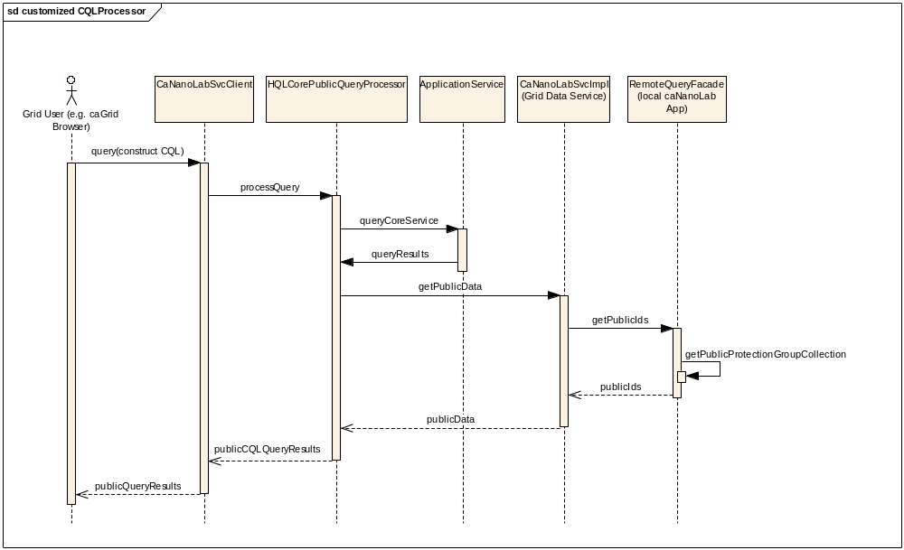
Figure 3-19: Sequence Diagram for Public Data Query through CQL

Remote File Content Retrieval
The remote report search function in the caNanoLab system involves retrieving reports from remote caNanoLab grid services. Tests show that passing byte array of a report content back from a caGrid data service is very memory intensive, and service performance is significantly impacted. An alternative solution to returning byte array from a grid search is to pass back only the file ID of a remote report.
When a remote grid service passes back a file ID, the local caNanoLab application fires a direct remote call to the remote caNanoLab system associated with the remote grid service through the remote query façade described earlier. The remote caNanoLab system retrieves it’s the file from the associated file systems and pass the byte array back to the remote client, or the local caNanoLab application. Note that the remote caNanoLab application URL is assumed to share the same application server host as the SDK application service used for the remote caNanoLab grid service. The SDK application service URL is stored in the remote grid service metadata and can be dynamically retrieved when users click a file to download within a local caNanoLab application. The following diagram illustrates the scenario of a local caNanoLab application retrieves the content of a file located remotely at a remote caNanoLab application.
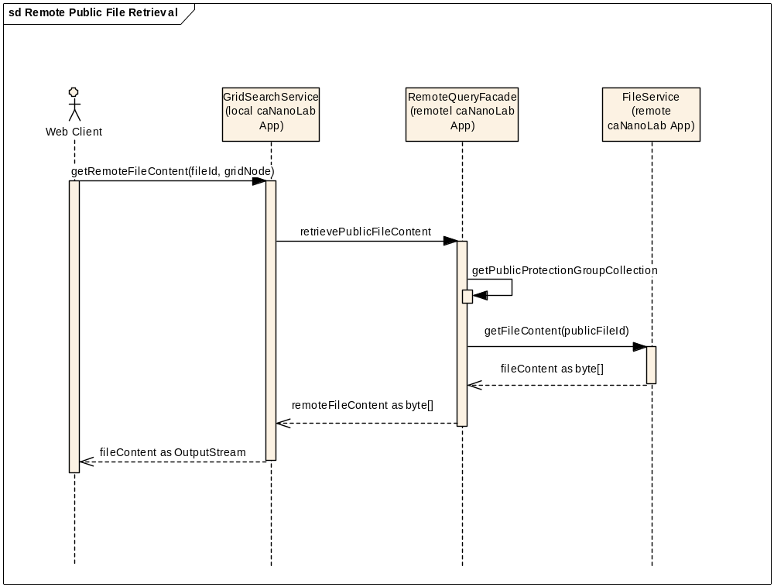
Figure 3-20: Remote File Content Retrieval Sequence Diagram

FILE repository STRUCTURE
In the caNanoLab system, users can upload files, and the uploaded files (reports, protocol files, characterization files, assay result files) are stored on a network file system accessible to the server that hosts the application server serving the caNanoLab application. A pre-defined directory structure and file naming conventions are employed to prevent uploaded files with same names overwriting each other. The following table describes the pre-defined directory structure for the different file types:

File Type | Directory Structure
Report | $ROOT/reports
Protocol | $ROOT/protocols
Characterization Files | $ROOT/particles/$PARTICLE_NAME/$CHAR_TYPE/
Assay Result Files | $ROOT/workflow_data/$ASSAY_TYPE/$ASSAY/$RUN/Input(or Output)

Table 3-1: Uploaded File Directory Structure: $ROOT is the file repository root specified by users as a caNanoLab build property; $PARTICLE_NAME, $CHAR_TYPE are dynamically generated when users upload characterization files associated with a particular particle and a characterization type; $ASSAY_TYPE, $ASSAY and $RUN are also dynamically generated when users upload assay result files associated with a particle assay type, assay and assay run, whether they are input files or output files).
When a file is uploaded, a timestamp in the format of yyyyMMdd_HH-mm-ss-SSS is added to the beginning of the filename as $NEW_FILE_NAME = $TIMESTAMP_$ORGINAL_FILENAME, e.g. 20061211_10-30-46-773_NCL200612A_fig 20.jpg. The new file name is saved to the appropriate directory on the file repository and file URI ($DIRECTORY/$NEW_FILE_NAME) is saved to the database.

Authentication and authorization
User authentication and authorization in the caNanoLab system are implemented using a customized version (with password encryption addition) of the CSM API version 3.1. In the caNanoLab system, the CSM database objects (prefixed with CSM) (shown in Figure 3-21) have been included under the same schema for storing the caNanoLab database objects.
During the caNanoLab application start up time, four different default user groups are created: PI, Researcher, Administrator, and Public, where PI, Researcher and Administrator groups are also prefixed with an application owner (e.g. NCL), which is specified in the application build properties. During the application startup time, the Public group is assigned privilege to access the SEARCH and the REMOTE SEARCH functions; the PI group is assigned to access the WORKFLOW, the INVENTORY and the SUBMIT functions; the Researcher group is assigned to access the WORKFLOW and the INVENTORY functions; the Administrator group is assigned to access the ADMINSTRATION functions and is responsible for managing user accounts and privileges in the UPT tool, a tool built and deployed as a separate web application when building the caNanoLab application.
The UPT tool has also been customized such that users in the Administrator group can no longer update users passwords. Administrators can only reset a user’s passwords by issuing an update to an existing user. A separate interface (visible on the caNanoLab log in page) has been implemented in the caNanoLab system to allow users to manage their own passwords. Before a user can access the caNanoLab application, he/she needs to be assigned to one or more user groups. The caNanoLab system assumes that every user is assigned to the Public group to see the SEARCH and the REMOTE SEARCH functions.

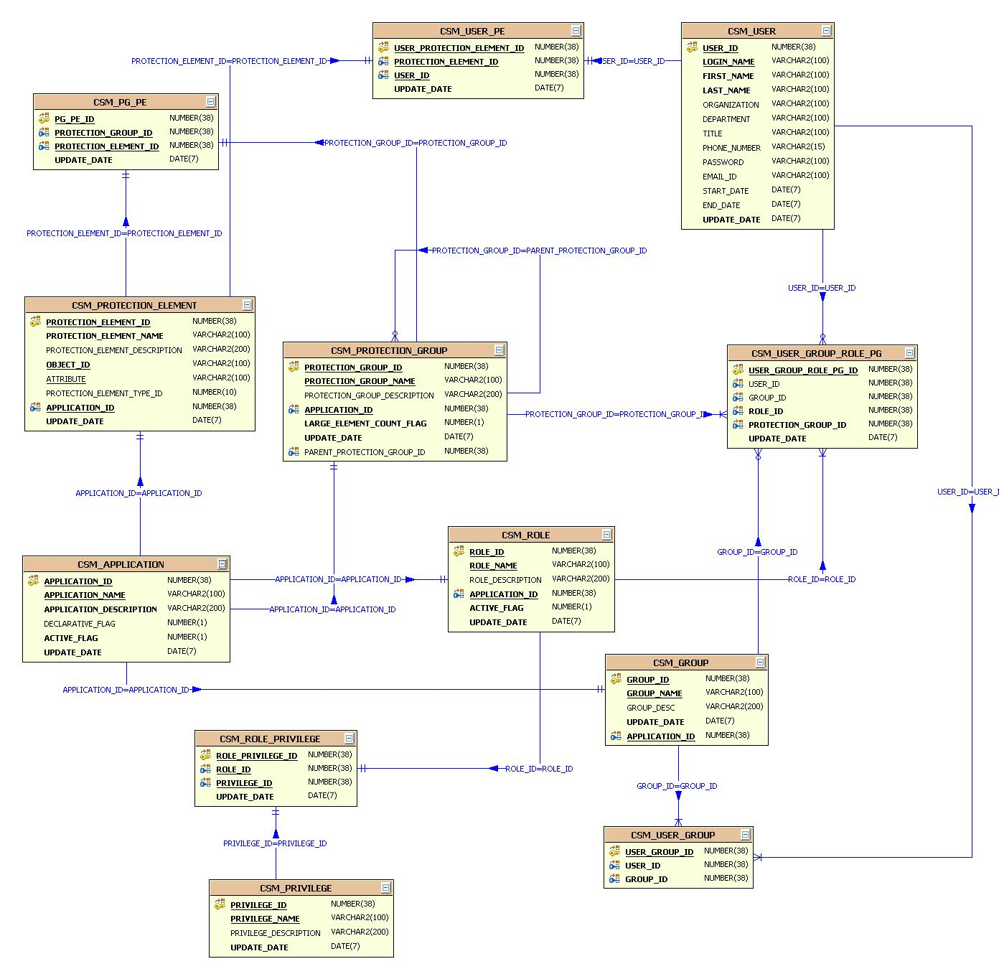
Figure 3-21: CSM Data Model

Grid-Enabling architecture
Since release 1.1, the caNanoLab domain model has been grid-enabled, meaning users can either fire CQLs against a deployed caNanoLab grid service to traverse through the caNanoLab object model and get public data from the model, or users can execute the custom grid operations to retrieve public nanoparticles, reports and composition data through the caNanoLab grid client. Since release 1.1, a production caNanoLab grid service has been deployed at the NCL serving grid clients public NCL nanoparticles and reports.

caNanoLab grid architecture overview
Figure 4-1 depicts components of an example grid-enabling architecture deployed at NCL. From the caNanoLab web application deployed at NCICBIIT, users can fire remote search queries to the caNanoLab grid service deployed at NCL. The NCL grid service uses the caCORE SDK application service deployed at NCL to retrieve data from the NCL caNanoLab database. Before returning the data to the client, the NCL grid service uses remote query façade to communicate with the NCL caNanoLab system to filter out non-public NCL data, and finally passes back only public NCL data to the NCICBIIT caNanoLab web application.
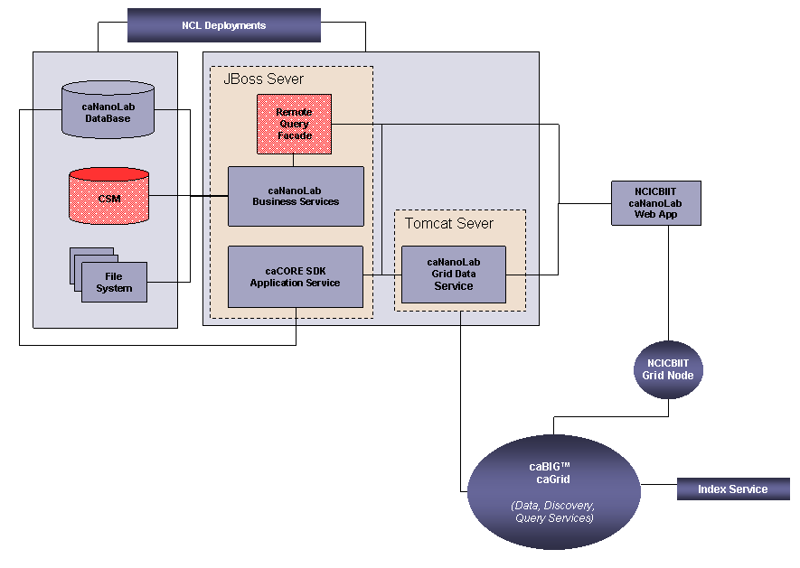
Figure 4-1: Grid-Enabling Architecture Diagram

caNanoLab grid data service
The core of a caNanoLab grid-enabling architecture is the caNanoLab grid data service. The codebase for the grid data service has been generated under the package gov.nih.nci.cagrid.cananolab using the caGrid 1.0 Introduce toolkit with POJO domain objects and hibernate OR mapping files packaged using the caCORE 3.1 SDK toolkit. Custom grid operations have been implemented in grid service implementation class gov.nih.nci.cagrid.cananolab.service.CaNanoLabSvcImpl. These operations as shown below allow grid clients to efficiently retrieve public nanoparticles, reports and composition data:
public Nanoparticle[] getNanoparticles(
String particleType,
String[] characterizationTypes,
String[] functionTypes) throws RemoteException

public Report[] getReports(
String reportTitle, String particleType,
String[] functionTypes) throws RemoteException

public AssociatedFile[] getOtherAssociatedFiles(
String title, String particleType,
String[] functionTypes) throws RemoteException

public Function[] getFunctionsByParticleName(
String particleName) throws RemoteException

public Characterization[] getCharacterizationsByParticleName(
String particleName) throws RemoteException

public Source getSourceByParticleName(
String particleName) throws RemoteException

public Report getReportsByParticleName(
String particleName) throws RemoteException

public AssociatedFile[] getOtherAssociatedFilesByParticleName(
String particleName) throws RemoteException

Public ComposingElement[] getComposingElements(
long compositionId, String particleName)
throws RemoteException

public SurfaceGroup[] getSurfaceGroups(
long compositionId, String particleName)
throws RemoteException
public Characterization getCharacterization(
long characterizationId, String particleName)
throws RemoteException

public ComposingElement[] getComposingElements(
long compositionId, String particleName)
throws RemoteException

After a caNanoLab grid service is deployed to a Tomcat service container at context root wsrf-canano and registered with a production caGrid index server, these custom operations are published as service metadata along with the caNanoLab domain model and are viewable to the general public. The REMOTE SEARCH function in the caNanoLab system fires remote queries through these custom operations.

caNanoLab SDK data service
The caNanoLab grid data service has been implemented to use a caCORE SDK backed caNanoLab data source, meaning the grid service communicates with the associated caNanoLab database through the caNanoLab SDK application service. The caCORE SDK toolkit provides a robust set of tools for accessing domain object data using Java. Based on a Unified Modeling Language (UML) model of domain classes and database structure, SDK generates an application service that provides access to the data represented by domain model. The caNanoLab SDK application service has been generated through packaging caNanoLab domain objects and hibernate ORMs through the caCORE SDK toolkit.

Appendix A – acronym List
Acronym | Description
ABCC | Advanced Biomedical Computing Center
caBIG | Cancer Biomedical Informatics Grid
caCORE | Cancer Common Ontological Representation Environment
caDSR | Cancer Data Standards Repository
caNanoLab | Cancer Nanotechnology Laboratory Analysis Bench
CCNE | Cancer Center of Nanotechnology Excellence
CSM | Common Security Module
CSS | Cascading Style Sheet
DAO | Data Access Object
DTO | Data Transfer Object
EIS | Enterprise Information System
EVS | Enterprise Vocabulary Services
J2EE | Java 2 Enterprise Edition
JSP | Java Server Page
JSTL | JavaServer Pages Standard Tag Library
NCICBIIT | National Cancer Institute Center for Biomedical Informatics and Information Technology
NCL | Nanotechnology Characterization Laboratory
ORM | Object Relational Mapping
POJO | Plain Old Java Object
SDK | Software Development Toolkit
SSL | Secure Socket Layer
UI | User Interface
UML | Unified Modeling Language
UPT | User Provisioning Toolkit

